Psychiatry and addictions in the 20th century
International conference / colloque international
Organized by Anatole Le Bras and Marianna Scarfone
Strasbourg, 26-27 January 2023

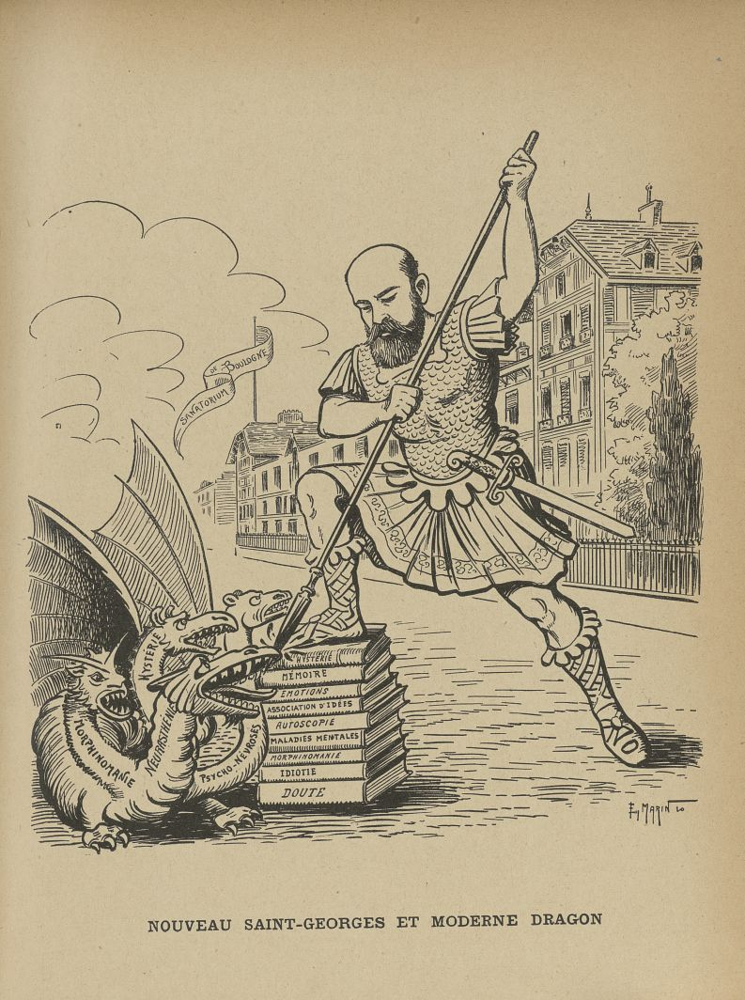
« Nouveau Saint-Georges et moderne dragon », L’Album du Rictus, journal humoristique mensuel, t. IV, Paris, 1910-1911. https://www.biusante.parisdescartes.fr/histmed/image?med24432x04x0087

The aim of this international conference is to explore psychiatry’s contribution to the troubled history of the medicalization of addictions in Europe throughout the 20th century. This question will be explored through the lens of medical concepts, institutions of care and cure, as well as patients’ experiences, with contributions from scholars from Belgium, France, Germany, Greece, Italy, Lithuania, Sweden, Switzerland and the UK.

Maison interuniversitaire des sciences de l’homme – Alsace
5, allée du Général Rouvillois, Strasbourg
Salle de la table-ronde
Free entry / entrée libre
Registration for the online broadcast / Inscription pour suivre l’événement en ligne :
anatole.lebras@unistra.fr & mscarfone@unistra.fr

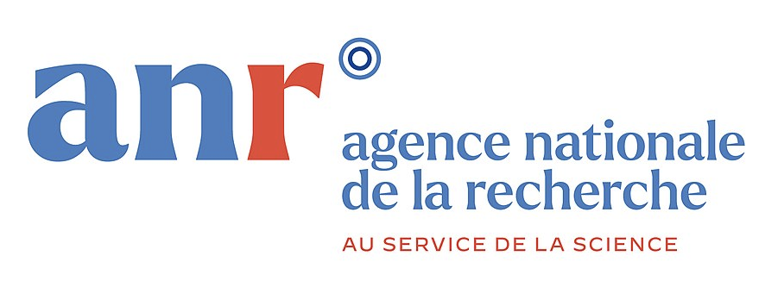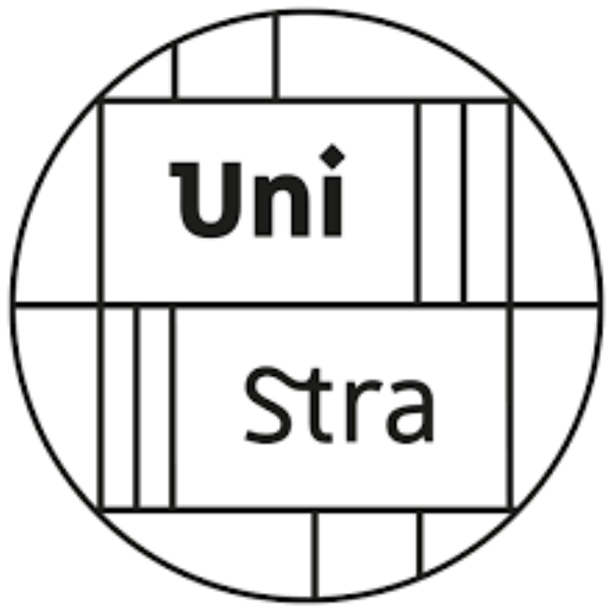

Program

26 January

2:00-2:30 pm | Anatole Le Bras and Marianna Scarfone, Introduction

Early 20th century: the uneasy conquest of new territories
Chair Virginia Berridge (London School of Hygiene and Tropical Medicine)

2:30-3:00pm | Zoë Dubus (Aix-Marseille University), Iatrogenic morphinomania and professional issues in the field of French psychiatry at the end of the 19th century
3:00-3:30pm | Victoria Afanasyeva (Paris-1-Panthéon-Sorbonne University), Breaking conventions: care for upper class alcoholics in La Source sanatorium in the suburbs of Paris (1902-1911)
3:30-4:00pm | Coffee break
4:00-4:30pm | Kostis Gotsinas (National Hellenic Research Foundation), Difficult patients: drug users and their treatment in early 20th century Greece
4:30-5:00pm | Rebecka Klette (University of London), Reclaiming the voice of a Swedish morphine addict at the beginning of the 20th century
5:00-5:30pm | Discussion

27 January

Alcoholic patients in and out of psychiatric institutions
Chair Anatole Le Bras (University of Strasbourg)

10:00-10:30am | Tomas Vaiseta (Vilnius University), When Everyone and No One Believes: A Treatment of Alcoholism in the Soviet Psychiatric Hospitals (1944-1990)
10:30-11:00am | Samuel Dal Zilio (University of Luxembourg), In and out of the mental hospital. Life paths of alcoholic patients in a Brussels psychiatric institution in the 1960s
11:00-11:30am | Marica Setaro (University of Strasbourg), Alcoholism and therapeutic community: the cultural, clinical and institutional dimensions of a difficult experiment. Gorizia 1965-1971
11:30-12:00am | Discussion
12:00am-1:30pm | Lunch break

Late 20th century: psychiatric deinstitutionalization and new conceptualizations of addictions
Chair Alexandre Marchant (ENS Paris-Saclay)

2:00-2:30pm | Vanessa Roghi (Lumsa University), Between democratic psychiatry and the institutionalisation of the drug addict. Italy 1975-1980
2:30-3:00pm | Oliver Falk (Universitätsmedizin Berlin – Charité), Berlin (West) on Drugs – How Heroin use affected the psychiatric reconceptualization of drug addiction and its treatment, 1970-1990
3:00-3:30pm | Raphaël Tinguely (University of Lausanne), Binge Watching: An Archeology of the “Addiction” to TV series
3:30-4:00pm | Discussion
4:00-4:30pm | Virginia Berridge, Conclusion

